I chose a simple logo that reflects the dynamism and adventure of rafting. This logo should convey the feeling of excitement and contact with nature.

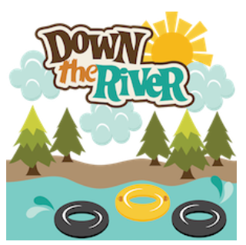

-Primary-color (#005f73): A deep blue reminiscent of water, perfect for a whitewater rafting theme. It's a calm and confident color, but also vibrant.

-Secondary-color (#fcbf49): A golden/yellow hue that provides a bright contrast, similar to the sun reflecting off of water, which is energizing and inviting.

-Accent1-color (#2d6a4f): An emerald green, evoking nature and the jungle landscapes near rafting rivers.

-Accent2-color (#f77f00): A warm orange that can be used for eye-catching details, such as buttons or call-to-action elements.

|  |  |  |
| --- | --- | --- |
| Label | Selected color | Hexadecimal code |
| primary-color | Ocean blue | #005f73 |
| secondary-color | Golden yellow | #fcbf49 |
| accent1-color | Emerald green | #2d6a4f |
| accent2-color | Bright orange | #f77f00 |

Selected sources:

• **heading-font**: **"Poppins"**

• **text-font**: **"Lora"**

Poppins: A modern, clean font, ideal for headers. Its geometric design gives it a touch of professionalism without losing its freshness.

Lora: A classic serif font that is easy to read in long paragraphs, perfect for body text, giving it a friendly and accessible touch.

Color palette URL link on Coolors.co:

https://coolors.co/005f73-fcbf49-2d6a4f-f77f00